**Simulation of Cryogenic Cooling of Materials: A Shell-Based Thermodynamic Modeling Tool for Low-Temperature Environments**

**1. Introduction**

Cryogenics is the branch of science that studies the behavior of materials and systems at extremely low temperatures, typically below 123 K (−150°C). Such conditions are commonly encountered in the aerospace industry, superconducting systems, cryopreservation, and quantum computing infrastructure. In these environments, the rate of thermal energy transfer and the corresponding temperature response of materials are critical parameters that influence system design, safety, and performance.

This project presents a simulation framework that models how different materials cool over time when exposed to cryogenic environments. It calculates temperature decay using Newton's Law of Cooling and estimates energy loss based on the thermal properties of each material. The model also incorporates the effect of object geometry (sphere, cube, or plate) on the cooling rate and supports multi-stage ambient temperature conditions to represent real-world thermal chambers.

The implementation is done entirely in Bash, using “bc” for floating-point math and “gnuplot” for generating time-series plots of temperature and energy loss. This approach demonstrates a lightweight, portable, and transparent way to simulate cryogenic thermal behavior without relying on large simulation libraries.

**2. Scientific Foundation**

**2.1 Cryogenic Environment**

Cryogenic systems typically operate using liquid cryogens such as:

* Liquid Nitrogen (77 K)
* Liquid Helium (4.2 K)
* Liquid Hydrogen (20.3 K)

When a material is placed in such an environment, its thermal state changes rapidly due to the steep temperature gradient. Understanding how temperature and energy evolve in this setting is essential for selecting appropriate materials and designing thermal protection mechanisms.

**2.2 Newton’s Law of Cooling**

The temperature change of an object in a cooler environment is governed by Newton’s Law of Cooling:



Where:

* *T(t)* is the object's temperature at time *t*
* *Ti*is the initial temperature
* *Ta*is the ambient temperature
* *k* is the material-dependent cooling constant

This exponential model assumes that the rate of heat loss is proportional to the temperature difference between the object and its surroundings.

**2.3 Energy Loss Calculation**

The thermal energy lost by the material as it cools is calculated using:



Where:

* *m* is mass (kg)
* *c* is specific heat capacity (J/kg·K)
* *Ti−T(t)* is temperature drop at time *t*

**3. Methodology**

The simulation accepts input parameters for multiple materials, including:

* Initial and final temperature
* Ambient temperature(s)
* Cooling constant kk
* Mass and specific heat
* Object shape (sphere, cube, plate)

The simulation proceeds by:

1. Iteratively computing *T(t)* using Newton’s Law.
2. Calculating *Q(t)*, the cumulative energy lost at each time step.
3. Adjusting the cooling constant based on shape (plate > cube > sphere).
4. Simulating ambient temperature shifts in multi-stage cryogenic chambers.
5. Writing data to .dat files and generating .png plots using gnuplot.

**4. Workflow & Simulation Logic**

Input: cryodata.txt

# Material Ti Tf TA K STEP Mass SpecificHeat Shape MultiStageTA

Aluminum 300 100 77 0.050 5 0.5 900 plate 77,70,60

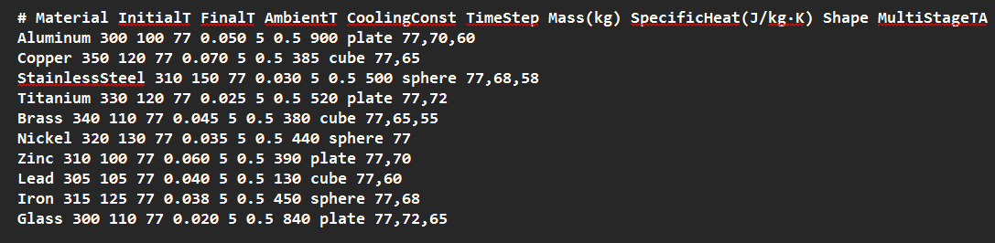

Key Steps:

1. Read input line by line, skipping headers.
2. Parse and store values like Ti, Tf, k, shape, and multi-stage ambient temperatures.
3. Adjust the cooling constant based on shape:
   * Sphere → *0.8k*
   * Cube → *k*
   * Plate → *1.2k*
4. Iterate through time steps until the final temperature is reached.
5. Switch ambient temperature at regular intervals if multiple stages are defined.
6. Compute and log *T(t)* and *Q(t)*.
7. Export plots with dual Y-axes: one for temperature, one for energy lost.

**5. Code Architecture & Explanation**

The simulation is implemented as a single Bash script, cryogenic_modeler.sh, which reads a structured dataset (cryodata.txt) and performs time-based thermal modeling for each material entry. The script is modular in design and follows a clean, logical progression from input parsing to simulation output.

5.1 Structure and Flow

The code is organized into the following logical blocks:

1. Pre-checks and Environment Validation

* Ensures that required tools (gnuplot, bc) are installed.
* Verifies that the input dataset exists.

1. Input Reading and Parsing

* Each line in cryodata.txt represents a material and its thermal parameters.
* The script reads these using a loop, skipping the header line, and extracts fields like initial temperature, cooling constant, mass, specific heat, shape, and ambient temperature stages.

1. Cooling Constant Adjustment Based on Shape
   * To reflect the impact of object geometry on thermal dissipation, the cooling constant k is modified based on shape:
     + Sphere: Slower cooling (reduced k)
     + Plate: Faster cooling (increased k)
     + Cube: Default (no adjustment)
   * This adjustment is performed using a simple function that returns a modified k value.
2. Simulation Loop (Temperature & Energy Calculation)
   * Time steps are iteratively processed until the target temperature is reached.
   * At each step:
     + Temperature is calculated.
     + Energy lost is calculated using.
     + The current time, temperature, and energy loss are written to a .dat file.
3. Multi-Stage Ambient Temperature Handling
   * If a material specifies multiple ambient temperatures, the simulation updates the ambient condition at fixed intervals (e.g., every 100 seconds).
   * This models real-world staged cooling processes such as vacuum chambers or nitrogen pre-cooling followed by helium immersion.
4. Data Logging and Output
   * A .dat file is generated for each material, containing tabulated values of time, temperature, and energy loss.
   * A corresponding .png plot is produced using gnuplot, showing:
     + Temperature vs. time
     + Energy loss vs. time (on a secondary Y-axis)
5. Terminal Reporting
   * For each simulation, the script prints:
     + Adjusted cooling constant
     + Total temperature drop
     + Total energy lost
     + Notifications for ambient temperature changes
     + Confirmation of plot and data file generation

**6. Results**

Each run generates:

* A .dat file with temperature and energy loss over time.
* A .png plot showing:
  + Temperature drop (K)
  + Energy loss (J)
* Terminal output showing:
  1. Adjusted cooling constant *k*
  2. Total energy loss *Q*
  3. Total temperature drop *ΔT*
  4. Stage change logs (e.g., *TA* = 70 K after 100s)

**Example output**:

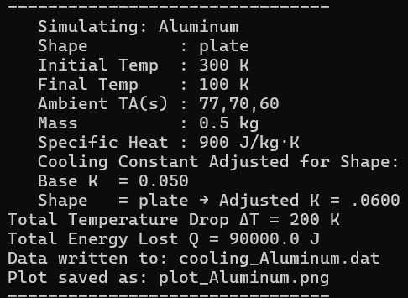

**7. Discussion**

This simulation is useful for approximating thermal behavior under cryogenic exposure. While not a high-fidelity numerical solver, it reliably illustrates:

* The exponential nature of cooling.
* How geometry impacts thermal dissipation.
* How staged environments affect final temperature and energy transfer.

Limitations:

* Assumes constant specific heat (independent of T).
* Shape adjustment is heuristic (not from surface area equations).
* No conduction/convection differentiation.

Despite this, the tool offers engineers and students a transparent way to model material cooling using basic tools and physical laws.

**8. Conclusion**

This project demonstrates a minimalistic yet scientifically valid approach to simulating cryogenic cooling behavior. By combining Newtonian thermodynamics, shape-aware adjustments, and multi-stage ambient modeling, it provides insight into material responses in extreme thermal environments. Implemented entirely in Bash, the tool is lightweight, reproducible, and ideal for educational use or as a basic module in more complex simulations.